**TEST CASES**

**Name:Dhruv Panchal**

**Roll NO;231070038**

**SY Btech Comp eng.**

Test Case 1:

- Input:

- Number of semesters: 2

- Semester 1:

- Number of courses: 3

- Credits: 3, 4, 2

- Grades: 10, 8, 6

- Semester 2:

- Number of courses: 2

- Credits: 4, 3

- Grades: 8, 9

- Expected Output:

- SPI for Semester 1: 8.2222

- SPI for Semester 2: 8.42857

- Overall CPI: 8.3254

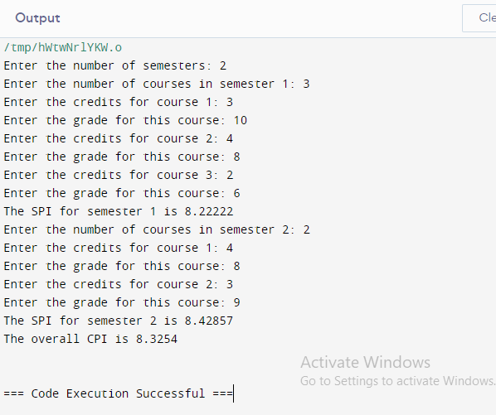

Test Case 2: -

Input:

- Number of semesters: 1

- Semester 1:

- Number of courses: 4

- Credits: 3, 3, 3, 3

- Grades: 10, 10, 10, 10

- Expected Output:

- SPI for Semester 1: 10.0

- Overall CPI: 10.0

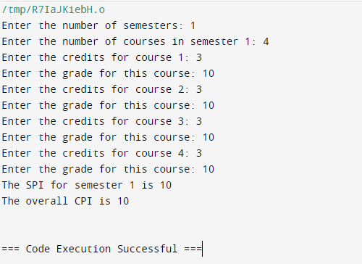

Test Case 3:

- Input:

- Number of semesters: 3

- Semester 1:

- Number of courses: 2

- Credits: 4, 4

- Grades: 8, 9

- Semester 2:

- Number of courses: 3

- Credits: 3, 3, 3

- Grades: 6, 8, 7

- Semester 3:

- Number of courses: 2

- Credits: 3, 4

- Grades: 9, 10

- Expected Output:

- SPI for Semester 1: 8.5

- SPI for Semester 2: 7.0

- SPI for Semester 3: 9.57143

- Overall CPI: 8.35714

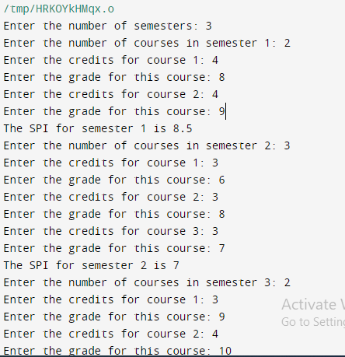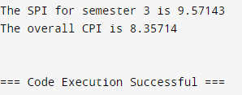

Test Case 4:

- Input:

- Number of semesters: 1

- Semester 1:

- Number of courses: 2

- Credits: 3, 4

- Grades: 12, 7

- Expected Output:

- Invalid grade 12

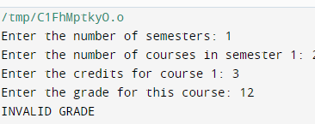

Test Case 5:

- Input:

- Number of semesters: 1

- Semester 1:

- Number of courses: 2

- Credits: 0, 4

- Grades: 8, 9

- Expected Output:

- Spi=9

